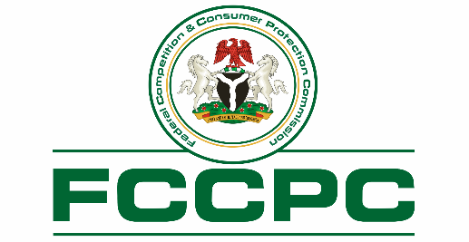

RELEASE

“LAGOS, ENUGU JUDGMENTS REINFORCE CONSUMER PROTECTION UNDER FCCPA” – TUNJI BELLO

Monday, October 27, 2025: The Federal Competition and Consumer Protection Commission (FCCPC) has welcomed recent court rulings that uphold consumer rights in Nigeria, notably the Lagos High Court’s award of ₦5 million in damages against Multichoice Nigeria Limited and the Enugu High Court’s decision declaring Peace Mass Transit’s “no refund” policy unlawful.

The Executive Vice Chairman and Chief Executive Officer of the FCCPC, Mr. Tunji Bello, commended the courts for ensuring fair outcomes that strengthen consumer confidence and accountability in the marketplace. He said the judgments show the strength of the Federal Competition and Consumer Protection Act (FCCPA), 2018, which empowers consumers to seek redress and requires service providers to meet lawful standards of fair service delivery.

Mr. Bello also praised the consumers for using lawful channels to pursue justice rather than recourse to self-help. He explained that the law provides several ways for consumers to express their grievances and that these decisions confirm the courts’ willingness to protect consumer rights.

Between March and August 2025, the Commission facilitated recoveries of more than ₦10 billion for consumers across 30 sectors, demonstrating the growing effectiveness of Nigeria’s consumer protection system. According to Mr. Bello, consistent judicial enforcement complements the Commission’s regulatory work and reinforces the message that consumer-rights violations attract real consequences. He urged consumers to continue reporting unfair practices through the FCCPC complaint portal, email, or any of its offices nationwide.

In one of the two decided cases, the Lagos High Court, presided over by Justice R. O. Olukolu, awarded ₦5 million in general damages to a DStv subscriber, Mr. Ben Onuora, for the wrongful disconnection of his active subscription. The Court found that Multichoice acted unlawfully by cutting off service despite verified payment, causing inconvenience to the claimant and his family. It ordered immediate reconnection and an extension to cover the period of disconnection, relying on Sections 130, 136, and 142–145 of the FCCPA 2018, which safeguard consumers’ rights to quality service and make suppliers liable for interrupted or defective delivery.

In the second case, the Enugu High Court, under Justice C. O. Ajah, ruled that Peace Mass Transit’s “no refund after payment” policy was illegal and void under Sections 120, 104, and 129(1) of the FCCPA 2018. The company was ordered to pay ₦500,000 in damages to a passenger, Mr. Tochukwu Odo, whose fare was withheld after an uncompleted trip. The Court held that service providers must refund consumers when a service is not rendered and that policies denying refunds breach statutory consumer rights.

The Federal Competition and Consumer Protection Commission (FCCPC) is Nigeria’s primary agency for consumer protection and competition regulation under the Federal Competition and Consumer Protection Act, 2018. The Commission promotes fair markets, safeguards consumer rights, and ensures accountability across all sectors.

Ondaje Ijagwu
Director, Corporate Affairs

